**ALBERT LEA PORT AUTHORITY**

**MINUTES**

**August 3, 2016- 7:00 a.m.**

**Regular Meeting**

**Albert Lea Business Development Center**

CALL TO ORDER & NOTATION OF ROLL

The Regular Meeting of the Albert Lea Port Authority was called to order on Wednesday, August 3, 2016 at 7:00 a.m. by President Heinemann. Roll was noted by the Board Secretary.

COMMISSIONERS PRESENT: Vern Rasmussen, Jr., Mike Moore, Al Brooks, Ginny Larson, Mark Heinemann, and Sarah Hensley

COMMISSIONERS ABSENT: Nate Jansen

EX-OFFICIO MEMBERS PRESENT: Chad Adams, City of Albert Lea representative; Randy Kehr, business community representative.

EX-OFFICIO MEMBERS ABSENT: Mike Lee, County Representative

STAFF MEMBERS PRESENT: Ryan Nolander – Executive Director, Shannon Berns – Business & Marketing Manager and Jillayne Raetz – Board Secretary

STAFF MEMBERS ABSENT: None

GUESTS: Bryan Skogheim – FMCS

APPROVAL OF MINUTES FROM JULY 6, 2016 MEETING

The minutes from the July 6, 2016 meeting were reviewed. Commissioner Rasmussen made a motion to approve the minutes as presented, seconded by Commissioner Brooks. President Heinemann asked for any discussion and hearing none, the motion carried 6 in favor; 0 opposed.

RESOLUTION PA-16-15 AUTHORIZING PAYMENT OF CLAIMS

The claims were presented for review. Commissioner Moore made a motion to accept the claims as presented in the amount of $21,225.10, seconded by Commissioner Rasmussen. President Heinemann asked for any discussion and hearing none, the motion carried 6 in favor; 0 opposed.

REVIEW PROPOSED 2017 BUDGET

The 2017 proposed budget was reviewed. The Port Authority general fund does not have a lot of revenue, the organization’s income shows up on the real estate/business fund. The revenue under charges for services that was there in the past will no longer be there because that was the income we received for doing JOBZ audits and the program no longer exists. In working with our auditors and accounting firm we have shifted a lot of expenses over to the business fund since that is where they are incurred. Bottom line for the general fund is negative due to having no income.

The business fund was reviewed next. The TIF revenue is from the TIF on the new spec building in the ALEDA industrial park. City Manager Adams asked about the TIF for the Larson Mfg. land that should start in 2017. It was realized that this was mistakenly excluded from the budget. Executive Director Nolander thanked Chad for mentioning this and explained that this is why we review the proposed budget a month before approving the final budget. Investment income is projected lower due to the cash going to pay for the new roof on south #1. Expenses are higher due to the shift in expenses from the general fund to the business fund that were previously discussed. A large increase to note is in advertising. Our current organization’s budget of $6500 isn’t sufficient to promote Albert Lea nationally/globally. Shannon is looking into the best options for ALEDA and the projected marketing plan is around $20,000, which is a large increase.

The overall combined budget summary shows a positive for 2017 and this will increase with adding the Largon Mfg. TIF revenue. Executive Director Nolander will make the needed adjustments over the next month and will present the final budget for approval at the September meeting.

EXECUTIVE DIRECTOR’S REPORT

* Ag Business Update
  + Last month there was a public hearing and vote to sell property on Plaza Street next to Freeborn Lumber for this project. Last Wednesday Executive Director Nolander received an email that the property sale is on hold now due to people issues. A mutual termination agreement needs to be signed, but now yesterday the potential buyer mentioned the project possibly could still happen. Executive Director Nolander will continue to work on this project and will update the board when he knows more.

* Enderes Property Update
  + Executive Director Ryan Nolander met with Troy Neist of Ventura. They have received the purchase agreement from us and their legal department is reviewing it. As a side note, Ventura corporate recently bought a company out of Canada. Albert Lea is one of their closest existing plants which could lead to more production locally, meaning more expansion and adding employees.
* South #1 Project and Roof Update
  + Executive Director Ryan Nolander, Troy Neist from Ventura and Tim from ZRT discussed the potential for converting the empty space in south #1 to refrigeration. Tim ran the numbers and it would be $1.2 – $1.3M to convert the 19,200 sq, feet. The cost makes this unrealistic for both the Port and Ventura, so Ventura is now looking at other ways to expand onsite and may use the empty space for ambient dry storage.
  + Construction has started on the roof project.

EX-OFFICIO UPDATE

Freeborn County – Mike Lee, Freeborn County Representative (absent)

* Executive Director Ryan Nolander said they are going through the budget process and that he will be presenting to the board on August 30th regarding support for the ALBDC.

City of Albert Lea – Chad Adams, City of Albert Lea Representative

* Primary election is next Tuesday the 9th. The Chamber hosted the candidate forums.
* The market values downtown have increased approximately 25%, showing that development has taken place there.
* There is still hope for a special session in August. Without a special session the LGA changes won’t be implemented, which means an approximate 2 ½ % levy increase will be needed just to cover this. Also, the Freeborn Bank building project would benefit from a special session.
* Small cities grant and loan program for downtown should be coming out this week.
* The watershed sales tax renewal final language will be on the council agenda next Monday night.
* Next budget workshop is Thursday night.
* Last month mentioned Tiger Hills’ lot sale. The property looks to go to tax forfeiture sale the end of September or early October. The city has a lot of money invested in infrastructure so the council is looking to buy or put a hold on the property. They want to recoup the investment so talking about setting the sale prices for the lots accordingly and also discussing other possible incentive programs.

Chamber of Commerce – Randy Kehr, business community representative

* Candidate forums were well attended. Interesting enough, most of the city council was there to watch.
* Lake City is undergoing main street construction straight through their town. MNDOT referred them to Albert Lea’s Broadway project as an example of how to successfully achieve a road diet and make a 3 lane concept work. They will go on a tour and discuss the process over lunch.
* The MN Supreme Court justices will be coming to Albert Lea on October 5th. There will be a dinner at Wedgewood Cove.
* This Saturday is the 4H livestock auction.

COMMISSIONER/OTHER ITEMS – None

RECESS THE MEETING

Due to going into a strategic planning session later, the meeting took a recess. Commissioner Brooks made a motion to recess the meeting, seconded by Commissioner Larson. The motion carried 6 in favor, 0 opposed. The meeting was recessed at 7:45am.

The meeting was reopened

at 8:45am for a strategic planning session. Commissioner Jansen arrived at 9:30am, Commissioner Rasmussen left at 10:45am. The notes of the strategic planning session will be included for approval with these minutes.

ADJOURNMENT

Commissioner Brooks made a motion to adjourn the meeting, seconded by Commissioner Larson. The motion carried 6 in favor, 0 opposed. The meeting adjourned at 11:00a.m.

Filed and attested August 3, 2016.

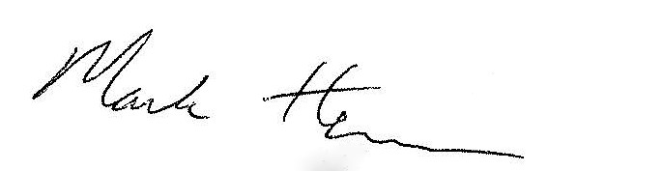 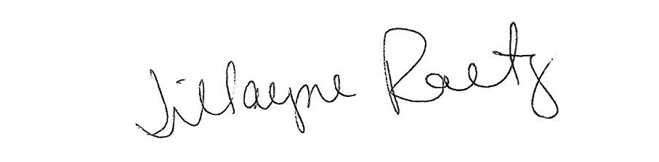

_____________________________ __________________________

President Board Secretary