**ALBERT LEA PORT AUTHORITY**

**MINUTES**

**September 7, 2016 - 7:30 a.m.**

**Regular Meeting**

**Albert Lea Business Development Center**

CALL TO ORDER & NOTATION OF ROLL

The Regular Meeting of the Albert Lea Port Authority was called to order on Wednesday, September 7, 2016 at 7:30 a.m. by President Heinemann. Roll was noted by the Board Secretary.

COMMISSIONERS PRESENT: Vern Rasmussen, Jr., Mike Moore, Al Brooks, Nate Jansen, Mark Heinemann, Sarah Hensley and Ginny Larson (8:00am)

COMMISSIONERS ABSENT: None

EX-OFFICIO MEMBERS PRESENT: Chad Adams, City of Albert Lea representative; Randy Kehr, business community representative; Mike Lee, Freeborn County representative

EX-OFFICIO MEMBERS ABSENT: None

STAFF MEMBERS PRESENT: Ryan Nolander – Executive Director and Jillayne Raetz – Board Secretary

STAFF MEMBERS ABSENT: None

GUESTS: Bryan Skogheim – FMCS, Ellen Kehr

APPROVAL OF MINUTES FROM AUGUST 3, 2016 MEETING

The minutes from the August 3, 2016 meeting were reviewed. Commissioner Rasmussen made a motion to approve the minutes as presented, seconded by Commissioner Brooks. President Heinemann asked for any discussion and hearing none, the motion carried 6 in favor; 0 opposed.

RESOLUTION PA-16-16 AUTHORIZING PAYMENT OF CLAIMS

The claims were presented for review. Commissioner Jansen made a motion to accept the claims as presented in the amount of $257,310.86, seconded by Commissioner Moore. President Heinemann asked for any discussion and hearing none, the motion carried 6 in favor; 0 opposed.

EMPLOYEE DISCUSSION

Shannon Berns is no longer with ALEDA. Sarah Hensley, Mark Heinemann and Executive Director Ryan Nolander had a meeting with Ms. Berns about work issues and it was decided that it would be best to terminate the employment relationship at this time. Randy Kehr informed Executive Director Nolander that Noelle Hagen could be interested in the open position at ALEDA. Executive Director Nolander offered a possible job share with her doing work for both the Chamber and ALEDA. Noelle is interested in this potential opportunity. The Chamber of Commerce board supports the idea. Noelle is in charge of the Leadership program, social media and website at the Chamber. At ALEDA she would manage the entrepreneur programming, social media, website and eventually all the marketing. Last month the board talked about the Chamber and ALEDA collaborating more and this could be a good first step. Financially it works for both organizations. Need to discuss the specifics with Stephanie Haedt, but she currently thinks the best structure would be part time employment with both organizations for liability reasons. Discussion followed. Commissioner Rasmussen likes that staff is thinking outside the box, but is concerned if a part time person can move the marketing plan forward that was discussed at the strategic planning session. Commissioner Jansen sees the need for a potential full time option. President Heinemann was concerned with what happens when/if we determine that we need a full time person. Other question, where does Noelle want to be? Randy Kehr thinks more full time at ALEDA. Commissioner Rasmussen wonders if we are missing out on someone who has economic development knowledge. Also, can she help people starting out a business in the ALEAP program? If ALEDA goes out and hires, it’s 2-3 month process with a couple more months of ramping up. It was decided that the interview committee will interview Ms. Hagen and will make a recommendation after that.

APPROVAL OF 2017 BUDGET

The revised budget was sent out yesterday. No major changes on the general fund. Increased revenues on the real estate/business fund to include the additional TIF revenue from the Larson Mfg. project. Changed personnel services to reflect the job share idea. It was decided to increase this expense back to where it was prior with the idea that the Small Business & Marketing Manager position will be full time. The advertising budget is still at $20,000. Commissioner Moore made a motion to approve the 2017 budget with the change to increase personnel services back to what it previously was, seconded by Commissioner Jansen. President Heinemann asked for any discussion and hearing none, the motion carried 6 in favor; 0 opposed.

EXECUTIVE DIRECTOR’S REPORT

* Ag Business Update
  + The developer finally did sign the mutual termination agreement for the purchase agreement. Hoping to move this project forward next spring.
* Enderes Property Update
  + The purchase agreement is still working through legal at Ventura.
* South #1 Roof Update
  + Construction has started. There was an issue one night during construction when the temporary overnight roof blew off during a storm with 70mph winds. Water got in the building and damaged some items. The roofing company is working with Ventura on resolving this situation.
* Collaboration Update
  + Gather – Randy Kehr, Sarah Hensley, Holly Karsjens, Jerry Gabrielatos, and Bob Furland have been working on forming this group, and Executive Director Nolander was asked to join the last meeting. Many people that move to town say that they have a hard time meeting new people other than those that they work with. This group is looking to create socialization opportunities for adults to meet new people through activities, hang outs and relaxed events. They are using Facebook for communication and the kickoff event is Oct 8th at 11:00am for a college football day at the Green Mill. Very casual and it’s important that people feel that they can meet other people and socialize.
  + Regional College Workforce Project - Jean Eaton is working on her project with the high school. Randy Kehr, Jerry Gabrielatos and Executive Director Nolander are working on this project to connect our regional colleges with our local employers. Idea is when the college student graduates there is an opportunity for them to stay in the community. Waldorf, NIACC and Riverland are very interested.
  + Northbridge Mall – This items was brought up at the county commissioner workshop. A commissioner was concerned with vacancies in the mall and didn’t want to see it turn into a similar situation like Oak Park Mall in Austin. Carrington out of California owns the mall and need to have a conversation with them. Maybe look at a retail incubator space or an indoor park? We just don’t want it to fall apart and become an empty space.
* City council work session
  + Executive Director Nolander and Randy Kehr attended a recent workshop to discuss ALEDA and tax base creation. Tax base creation is the #1 priority on the council’s goal list and so they wanted to have a conversation with the council about what is their vision for tax base creation. Somehow the discussion turned to immigration and never got back to tax base creation.
* Education Foundation Forum Sept. 8th
  + This is always a great forum with a very knowledgeable panel, the issue in the past is that nobody from the business community shows up to listen and participate. Executive Director Nolander will be one of the panelists and the discussion will revolve around the Greater Education project that Jean Eaton and the Education Foundation have been working on.

EX-OFFICIO UPDATE

Freeborn County – Mike Lee, Freeborn County Representative

* Working on the 2017 budget. Looking at around a 3.00% preliminary levy increase. They will set the preliminary in September.
* The ICE contract is bringing in more dollars than last year.
* They are looking to offer the county attorney position to David Walker. David is currently the assistant county attorney.

City of Albert Lea – Chad Adams, City of Albert Lea Representative

* The city has held 3 budget work sessions. Looking at a preliminary levy increase of 3.31% on Monday night. Operating levy has been frozen for 4 years.
* Small cities applications are out to downtown businesses. Deadline is a couple weeks out for grants and loans.
* Due to the lack of a bonding bill, the tax credits for the bank building project will be very competitive and could hinder the developer receiving the needed credits. The application has gotten stronger each time.
* Sales tax renewal for the watershed will be on the ballot in November.

Chamber of Commerce – Randy Kehr, business community representative

* The MN Supreme Court will be visiting Albert Lea on October 5th and 6th. Tickets for the dinner on the 5th are available on the website or at the Chamber office.
* The Chamber will be running the candidate forums for the upcoming elections.
* Lake City came to town to discuss the South Broadway road diet project. They toured the project and had a discussion with local leaders. 4 days later they voted 5 to 2 to incorporate a road diet into their road construction project.
* A group from Shawnee, Oklahoma will visit Albert Lea Sept 22nd for the day to discuss the Blue Zones project.
* Recently results for the Blue Zones Gallup poll were released. The poll showed a significant move forward as far as how residents view the community and the Blue Zones project. 85% of those polled stated that Albert Lea is a great place to live. Previously Albert Lea’s well-being index was 3 points below the national average and it is now at the national average. Significant improvement.

COMMISSIONER/OTHER ITEMS

* Commissioner Rasmussen – Wants to make sure we move forward with the marketing plan. Executive Director Nolander stated it’s on hold until we can solve the staffing issue. He also wanted us to continue to look outside the box at projects. Continue to look at the long term.
* Commissioner Brooks – Reiterated that we need to listen to Commissioner Rasmussen’s comments on moving forward. Executive Director Nolander stated again that we need to solve the staffing issue before we can move forward with other programming.

ADJOURNMENT

Commissioner Brooks made a motion to adjourn the meeting, seconded by Commissioner Rasmussen. The motion carried 7 in favor, 0 opposed. The meeting adjourned at 8:40a.m.

Filed and attested September 7, 2016.

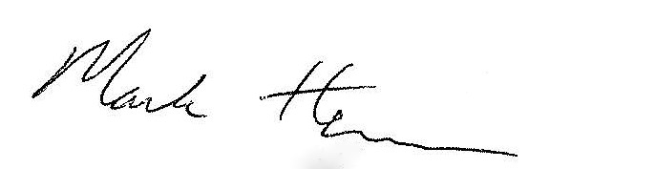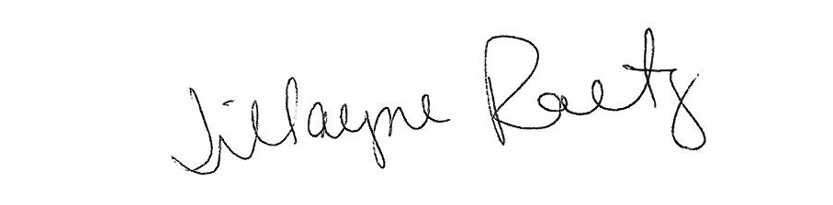____________________________ __________________________

President Board Secretary