**ALBERT LEA PORT AUTHORITY**

**MINUTES**

**Wednesday, October 5, 2016- 7:30 a.m.**

**Regular Meeting**

**Albert Lea Business Development Center**

CALL TO ORDER & NOTATION OF ROLL

The Regular Meeting of the Albert Lea Port Authority was called to order on Wednesday, October 5, 2016 at 7:30 a.m. by President Heinemann. Roll was noted by the Board Secretary.

COMMISSIONERS PRESENT: Vern Rasmussen, Jr., Mike Moore, Al Brooks, Nate Jansen, Mark Heinemann, and Sarah Hensley

COMMISSIONERS ABSENT: Ginny Larson

EX-OFFICIO MEMBERS PRESENT: Chad Adams, City of Albert Lea representative; Randy Kehr, business community representative; Mike Lee, Freeborn County representative

EX-OFFICIO MEMBERS ABSENT: None

STAFF MEMBERS PRESENT: Ryan Nolander, Executive Director and Jillayne Raetz, Board Secretary

STAFF MEMBERS ABSENT: None

GUESTS: Bryan Skogheim – FMCS

APPROVAL OF MINUTES FROM SEPTEMBER 7, 2016 MEETING

The minutes from the September 7, 2016 meeting were reviewed. Commissioner Rasmussen made a motion to approve the minutes as presented, seconded by Commissioner Brooks. President Heinemann asked for any discussion and hearing none, the motion carried 6 in favor; 0 opposed.

RESOLUTION PA-16-17 AUTHORIZING PAYMENT OF CLAIMS

The claims were presented for review. Executive Director Nolander noted the payment for the new roof on South #1 and over $83,000 in property taxes as the reason for the large claims amount this month. Commissioner Rasmussen made a motion to accept the claims as presented in the amount of $245,364.33, seconded by Commissioner Moore. President Heinemann asked for any discussion and hearing none, the motion carried 6 in favor; 0 opposed.

SMIF PRESENTATION – Tim Penny, President and CEO

SMIF’s President and CEO Tim Penny presented to the board. SMIF is celebrating 30 years. Their

focus is in three areas: community funds, early childhood development, and economic development focused on entrepreneurial activity. They have partnered with many organizations in Freeborn County. Discussion followed with the board and staff thanking Tim for his time and continued partnership.

EMPLOYEE DISCUSSION

Last month Executive Director Ryan Nolander and Randy Kehr brought forth the idea of collaborating on a job share position with Noelle Hagen. The board decided that there could be a job share during a transition period, but that we needed a full time person in that position. The board requested staff and the interview committee conduct an interview with Noelle. The interview took place October 12th. She recently graduated with a degree in business management and has been working at the Chamber while going to school and after graduation, which means she has experience working with a non-profit community focused organization. She has a strong work ethic, she handled herself well during the interview, and was honest about what she knows verses what she doesn’t. She can help get the message out to the public and people in her age group. She knows what’s going on in the community due to working at the Chamber. She is professional and mature beyond her years, a talented young person wanting to be involved in the community. She is not afraid to challenge and will bring fourth new ideas, new perspective. Currently at the Chamber she is doing a number of the things we would want her to handle at ALEDA. Executive Director Nolander and Randy Kehr met with Stephanie Haedt to discuss the employment situation. Stephanie said to have her be a part time employee at both organizations during the transition period, with an unwritten goal of being full time at ALEDA sometime in the future. The burden is on Randy and the Chamber to figure out how they want to structure their staff going forward. City Manager Adams asked about a probation period. Executive Director Nolander said that he was told not to do a probation period by ALEDA’s employment law attorney, but he will confirm that with her. The board discussed the position and recommended that staff move forward with a job share for the transition period, invest time in training, with the ultimate goal to move forward full time in the near future.

EXECUTIVE DIRECTOR’S REPORT

* Enderes Property Sale Update
  + Still going through legal at Ventura. They did recently ask for a copy of the farm lease for the property.
* DEED Prospect- niche beverage manufacturer
  + DEED approached us and other communities about this prospect. They are looking for existing vacant space. Executive Director Nolander pitched the vacant space in South #1. Very early in the process.
* South #1 Warehouse Project
  + Approached by a company about a warehouse project. They are interested in the vacant space in South #1 and have some very specific infrastructure requirements that need to be worked through.
* Collaboration Update
  + Gather- First event was held Oct. 8th at the Green Mill. Looking to offer adults opportunities to interact with other adults. Sarah Hensley mentioned that the organizing committee would love to have it planned out a quarter at a time.
  + Regional College Workforce Project- Local group working on connecting regional colleges with our local businesses. Currently have Waldorf, NIACC and Riverland interested.
  + Riverland’s FAB Project- FAB stands for Food, Ag and Bio. Executive Director Nolander and Randy Kehr met with Nuga and Steve Bowron from Riverland to discuss the programs and potential for a FAB facility. They are trying to help them connect with partners and Riverland wants to be recognized as best in class. Need to go to local FAB businesses and get their input on the current programs and how to structure the program going forward.
* Education Foundation Forum Sept 8th
  + Once again a great discussion, but disappointing that there wasn’t any representation from business or industry. Need to figure out how to reach that population.

EX-OFFICIO UPDATE

Freeborn County –Mike Lee, Freeborn County Representative

* Flood damage estimated at $1.7 to $2 million. FEMA is coming down next week.
* 2017 proposed tax levy was $21M or a 2.5% increase, hope to lower this in December.
* There was a question about communication during the recent flood events. Communication needs to be addressed to work together better with customers, nonprofit and other community organizations.

City of Albert Lea – Chad Adams, City of Albert Lea Representative

* The market rate rentals at Wedgewood have been well received and the owners are looking at phase 2.
* Ramsey school housing project is moving forward. Targeting rentals with studio apartments and 2 bedrooms. A second phase is planned for the future.
* Freeborn Bank building tax credit decision will be known in the next 10-15 days.
* The council is discussing sending out an RFP for phase 1 of the Blazing Star Landing project.
* There will be an upcoming regional housing summit. In the meantime the city is looking at potential incentives to spur new housing starts.
* At a recent ICMA conference there were sessions with Retail Strategies and the National Development Council. Executive Director Nolander mentioned that he spoke with Retail Strategies in January and discussed their proposal at our February board meeting. As for NDC, Executive Director Nolander is familiar with them as he received his Economic Development Finance Professional designation from them. They could definitely be a resource should we ever need to use New Market Tax Credits, as NMTCs are very complicated.
* Downtown small cities program currently has 11 applications, and there are currently more projects interested in the façade program.
* Even with increased tax base in the community, the council approved a preliminary tax levy increase of 3.3% due to the LGA increase not being approved during this year’s session. Still looking at ways to lower this before finalized in December.

Chamber of Commerce – Randy Kehr, business community representative

* The Leadership program has Government Day in November.
* MN Supreme Court is in town tonight. So far 150 guests are registered for dinner. Tomorrow they will hold an oral argument at the high school. Really pleased with District 241, they are doing an extraordinary job.
* Candidate forums for the city, school board and county board are coming up.
* Chamber annual meeting is on the 27th.
* Blue Zones project continues to go well. We have been certified and the recent Gallup Poll results show significant changes have been accomplished. Up to us to promote it, people coming from all over the world to do stories on the Blue Zones and Albert Lea.

COMMISSIONER/OTHER ITEMS –

* Commissioner Brooks mentioned that part of the Universal Tire warehouse is once again being used. A new 5-year lease and may expand it. Not a lot of employees, new office and warehouse.

ADJOURNMENT

Commissioner Brooks made a motion to adjourn the meeting, seconded by Commissioner Jansen. The motion carried 6 in favor, 0 opposed. The meeting adjourned at 8:55a.m.

Filed and attested October 5, 2016.

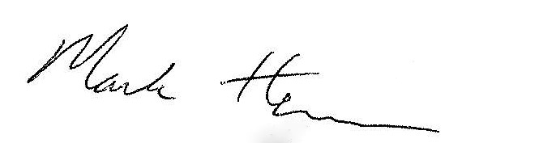 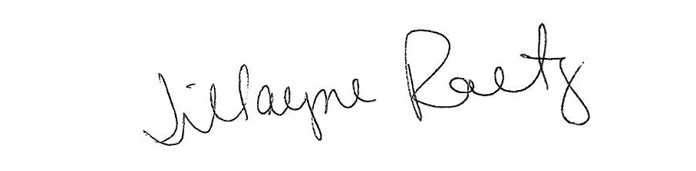

_____________________________ __________________________

President Board Secretary