**ALBERT LEA PORT AUTHORITY**

**MINUTES**

**Wednesday March 1, 2017 - 7:30 a.m.**

**Regular Meeting**

**Albert Lea Business Development Center**

CALL TO ORDER & NOTATION OF ROLL

The Regular Meeting of the Albert Lea Port Authority was called to order on Wednesday March 1, 2017 at 7:30 a.m. by President Heinemann. Roll was noted by the Board Secretary.

COMMISSIONERS PRESENT: Vern Rasmussen, Jr., Mike Moore, Rich Murray, Nate Jansen, Ginny Larson, Mark Heinemann, and Sarah Hensley

COMMISSIONERS ABSENT: None

EX-OFFICIO MEMBERS PRESENT: Randy Kehr, business community representative; Mike Lee, Freeborn County representative

EX-OFFICIO MEMBERS ABSENT: Chad Adams, City of Albert Lea representative

STAFF MEMBERS PRESENT: Ryan Nolander, Executive Director; Noelle Hagen, Small Business & Marketing Manager and Jillayne Raetz, Board Secretary

STAFF MEMBERS ABSENT: None

GUESTS: Brian Skogheim - FMCS, Jerry Gabrielatos - City of Albert Lea

APPROVAL OF MINUTES FROM FEBRUARY 1, 2017 MEETING

The minutes from the February 1, 2017 meeting were reviewed. A couple minor changes were recommended by President Mark Heinemann via email, changes were made by Executive Director Nolander. Commissioner Larson made a motion to approve the minutes as presented, seconded by Commissioner Rasmussen. President Heinemann asked for any discussion and hearing none, the motion carried 7 in favor; 0 opposed.

RESOLUTION PA-17-07 AUTHORIZING PAYMENT OF CLAIMS

The claims were presented for review. Commissioner Jansen made a motion to accept the claims as presented in the amount of $18,940.01, seconded by Commissioner Moore. President Heinemann asked for any discussion and hearing none, the motion carried 7 in favor; 0 opposed.

EXECUTIVE DIRECTOR’S REPORT

* Project T-Wave
  + There was a meeting in St. Paul on February 10th with DEED and the company. Executive Director Nolander and SB&M Manager Hagen attended along with representatives from the City, County and FMCS. We submitted our incentive response last Friday and expect it to be a couple weeks before we hear more. They are looking to buy the property in 2017, construction in 2018 and open in the fall of 2019.
* Trail’s Truck Service Center
  + They are looking to expand the truck service center and Executive Director Nolander met with them to discuss their project and potential incentive options.
* ZRB Expansion Project
  + Executive Director Nolander is meeting with Tim from ZRT to look at the latest design for the building and storm water pond. They are also meeting with ZRB tomorrow morning to review the current building design. Bid opening is being planned for March 31st. Nolander continues to work on the financing, working with the City for the access property to Sykes and admin survey, and preparing all the legal paperwork with our attorney.
* Carpenter Building
  + Haven’t heard back on the property sale. They have also asked for 3 year and 5 year lease options, staff is currently working on those.
* Annual Audit
  + The auditors are here this week. Executive Director Nolander is working on the process of combining the Port Authority’s general and real estate funds into one fund for ease of banking, financial statements, budgeting, etc. In discussing this with the auditors it looks like doing the process mid-year would be the best option. He will continue to work on this.
* Collaboration & Education:
  + Regional College Workforce Project – The website will be completed next month. Waldorf is hosting mock interviews for their students and are looking for business people to participate. Staff sent this info out to the Greater Job members.
  + Gather Program - Last Thursday was game night. Book club is next Thursday. Members are continuing to look for ways to connect people.

EX-OFFICIO UPDATE

Freeborn County – Mike Lee, Freeborn County Representative

* The board recently approved labor agreements with multiple bargaining units.
* The county received $9,500 from SMIF for healthy family home visits.
* Mike went over the major county road projects for 2017.
* March 9th is the next city council/county board workshop.

City of Albert Lea – Jerry Gabrielatos, City of Albert Lea Representative

* Hired a full time finance director.
* Small cities grant and loan program continues to move forward.
* Jerry mentioned the council approved road projects last Monday.
* Work continues on the expansion of the city garage.
* Started promoting the South Broadway façade program.
* Yesterday Jerry and the Mayor met with representatives from the Carrington Company, the owners of the Northbridge Mall. They discussed ideas for marketing the mall space and potential options for empty spaces.

Chamber of Commerce – Randy Kehr, business community representative

* The middle school workforce program continues to go well and businesses are being receptive.
* The Ag lunch will be March 21 at the Fairlane building, with a comedian as the speaker. Seating is limited, call the Chamber for tickets.

COMMISSIONER/OTHER ITEMS -

* There is a nonprofit board training next week at the museum on Tuesday the 7th. Executive Director Nolander will be attending, join him if you can.

ADJOURNMENT

Commissioner Moore made a motion to adjourn the meeting, seconded by Commissioner Jansen. The motion carried 7 in favor, 0 opposed. The meeting adjourned at 8:20a.m.

Filed and attested March 1, 2017.

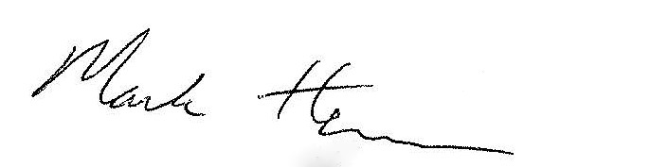 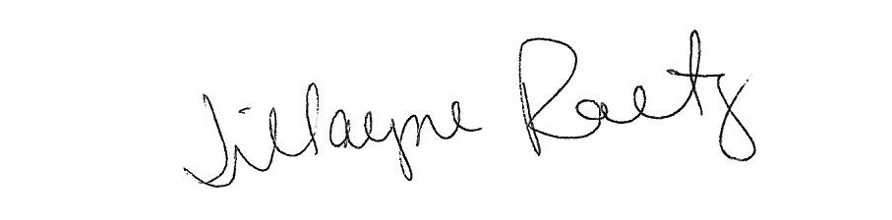

_____________________________ __________________________

President Board Secretary