**ALBERT LEA PORT AUTHORITY**

**MINUTES**

**Wednesday April 5, 2017- 7:30 a.m.**

**Regular Meeting**

**Albert Lea Business Development Center**

CALL TO ORDER & NOTATION OF ROLL

The Regular Meeting of the Albert Lea Port Authority was called to order on Wednesday, April 5, 2017 at 7:30 a.m. by President Heinemann. Roll was noted by the Board Secretary.

COMMISSIONERS PRESENT: Vern Rasmussen, Jr., Mike Moore, Rich Murray, Ginny Larson, Mark Heinemann, and Sarah Hensley

COMMISSIONERS ABSENT: Nate Jansen

EX-OFFICIO MEMBERS PRESENT: Chad Adams, City of Albert Lea representative; Randy Kehr, business community representative; Mike Lee, Freeborn County representative

EX-OFFICIO MEMBERS ABSENT: None

STAFF MEMBERS PRESENT: Ryan Nolander, Executive Director; Noelle Hagen, Small Business & Marketing Manager and Jillayne Raetz, Board Secretary

STAFF MEMBERS ABSENT: None

GUESTS: Brian Skogheim- FMCS

APPROVAL OF MINUTES FROM MARCH 1, 2017 MEETING

The minutes from the March 1, 2017 meeting were reviewed. Commissioner Rasmussen made a motion to approve the minutes as presented, seconded by Commissioner Moore. President Heinemann asked for any discussion and hearing none, the motion carried 5 in favor; 0 opposed.

RESOLUTION PA-17-08 AUTHORIZING PAYMENT OF CLAIMS

The claims were presented for review. Commissioner Moore made a motion to accept the claims as presented in the amount of $15,558.62, seconded by Commissioner Rasmussen. President Heinemann asked for any discussion and hearing none, the motion carried 5 in favor; 0 opposed.

(*Commissioner Murray arrived)*

EXECUTIVE DIRECTOR’S REPORT

* Project T Wave
  + Latest email from DEED stated that our proposal is still under consideration and it sounds like we will know more in the next 30 days. They stated that the last time they spoke with the company they were impressed with our response.
* ZRB Expansion
  + The bid opening that was scheduled for March 31st has been moved to April 19th. There were a bunch of alternates added to the bid and the contractors requested more time to pull their bids together. The financial institutions, our bond council, North American Title and our legal team are on board with the change and the project. Once bids are opened we need to sit down with ZRB and agree upon alternates and ultimately who pays for what.
* Carrington Company Call and Marketing
* Last month Mayor Rasmussen and Jerry Gabrielatos met with, and Executive Director Nolander spoke with, the new special projects manager for Carrington Company (aka Northbridge Mall). He is interested in working with community partners and is open to different ideas for filling spaces at the mall. Good to see them reaching out and wanting input.
* St. John’s New Facility Tour
* City Manager Adams, Assistant City Manager Gabrielatos, Mayor Rasmussen and Executive Director Nolander toured the new campus. Discussion followed on the incentive package that was approved. The TIF that was approved means potentially no new property tax income for up to 26 years. There was some incentive for the city to participate as it allowed them to oversize the water and sewer to this project, which will eventually help get these services to the Stable’s area. It is an impressive project and spaces are starting to fill up.
* Property Tax Review
* Executive Director Nolander provided a hand out with all of ALEDA’s properties and the amount they pay in property taxes and assessments. ALEDA will pay over $240,000 in 2017 for taxes and assessments. The point was made that not only does ALEDA not levy a tax, they also pay taxes.
* Nonprofit Board Training Session
  + Executive Director Nolander passed out information he obtained from the nonprofit board training he attended at the museum. It contained the fiduciary duties of board members and he walked the board through the information.

EX-OFFICIO UPDATE

Freeborn County – Mike Lee, Freeborn County Representative

* The County board passed a smoking ban for county grounds effective July 1st. County parks are not included in this ban.
* The comprehensive water plan will be completed in 2 weeks.
* The board is considering the new housing tax abatement program in 2 weeks.
* Freeborn Wind Energy LLC is looking to build a wind farm east of Glenville and into northern Iowa.
* Yesterday the board passed the resolution supporting the watershed’s petition request for the dredging project.

City of Albert Lea – Chad Adams, City of Albert Lea Representative

* Legislative update: the sales tax for the watershed is going well, workforce housing programs are receiving good feedback, the MPCA rules look to be changing to require scientific review, and the bonding bill discussion has remained fairly quiet. Hoping for a bonding bill that contains dollars for the Stable’s project and finishing the Blazing Star Trail.
* GoldCross project was approved, April 25th will be the ground breaking.
* May 15th is the confirmed date for the regional housing summit in Rochester. Discussion will revolve around solutions for workforce housing and case studies.
* The Wedgewood and Ramsey school housing projects continue to move forward.
* Cedar House, a mental services business, has purchased land behind the Shell Rapid Lube for a new building, but now are looking at another option of buying an existing building. A new building would create tax base and they look to add jobs.
* Cohen-Esrey didn’t resubmit their tax credit application for the Freeborn Bank Building project. The request for RFP resulted in 2 local proposals that will be reviewed.
* The public works facility bids came in lower than estimated, moving forward with the project.

Chamber of Commerce – Randy Kehr, business community representative

* Held the Ag Lunch in March, comedian was enjoyable.
* Chad Adams and Randy Kehr met with Secretary of State last week about new programs and information available through the state on their website.
* Monday there was the youth summer job fair at the high school. Significantly better than last year, 13 businesses participated. There is also an upcoming job fair at Northbridge Mall, with companies trying to recruit employees.
* Today representatives from the MN Chamber will be in town meeting with the Tribune on the proposed changes with the state wide business property taxes and other items.
* Next Tuesday Executive Director Nolander and Chamber Director Kehr will be participating in business visits with the MN Chamber. They will be visiting MN Freezer Warehouse, Pro Manufacturing and Select Foods.
* Continue to get positive feedback about the Blue Zones project from all over the world.

COMMISSIONER/OTHER ITEMS – None

ADJOURNMENT

Commissioner Moore made a motion to adjourn the meeting, seconded by Commissioner Hensley. The motion carried 6 in favor, 0 opposed. The meeting adjourned at 8:25 a.m.

Filed and attested April 5, 2017.

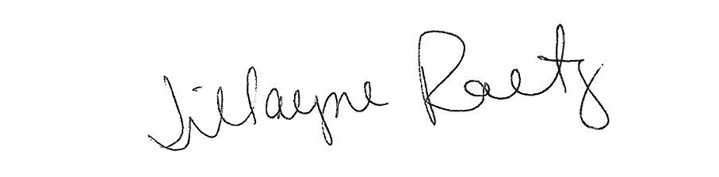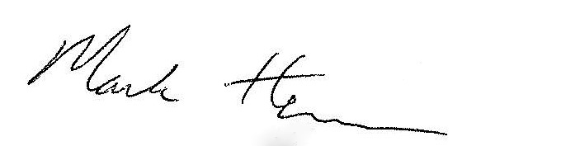

_____________________________ __________________________

President Board Secretary