**ALBERT LEA PORT AUTHORITY**

**MINUTES**

**Wednesday, August 2, 2017- 7:30 a.m.**

**Regular Meeting**

**Albert Lea Business Development Center**

CALL TO ORDER & NOTATION OF ROLL

The Regular Meeting of the Albert Lea Port Authority was called to order on Wednesday August 2, 2017 at 7:30 a.m. by President Heinemann. Roll was noted by the Board Secretary.

COMMISSIONERS PRESENT: Vern Rasmussen, Jr., Mike Moore, Rich Murray, Nate Jansen, Ginny Larson, Mark Heinemann, and Sarah Hensley

COMMISSIONERS ABSENT: None

EX-OFFICIO MEMBERS PRESENT: Chad Adams, City of Albert Lea representative; Mike Lee, Freeborn County representative

EX-OFFICIO MEMBERS ABSENT: Randy Kehr, business community representative

STAFF MEMBERS PRESENT: Ryan Nolander, Executive Director; Noelle Hagen, Small Business & Marketing Manager; Jillayne Raetz, Board Secretary

STAFF MEMBERS ABSENT: None

GUESTS: Brian Skogheim – FMCS

APPROVAL OF MINUTES FROM JULY 12, 2017 MEETING

The minutes from the July 12, 2017 meeting were reviewed. Commissioner Jansen made a motion to approve the minutes as presented, seconded by Commissioner Rasmussen. President Heinemann asked for any discussion and hearing none, the motion carried 7 in favor; 0 opposed.

RESOLUTION PA-17-18 AUTHORIZING PAYMENT OF CLAIMS

The claims were presented for review. Commissioner Rasmussen made a motion to accept the claims as presented in the amount of $18,686.84, seconded by Commissioner Moore. President Heinemann asked for any discussion and hearing none, the motion carried 7 in favor; 0 opposed.

APPROVE 3 YEAR BUILDING LEASE WITH CARPENTER COMPANY

Executive Director Nolander has been working with Carpenter on a sale, 3-year lease and 5-year lease options. Carpenter has settled on the 3-year lease option. Carpenter’s lease rate has been a little lower due to keeping the rate the same for many years in the 1990s and early 2000s. The current lease rate is $2.10/sf triple net and the new proposed 3-year rate is $2.25/sf triple net. This equates to a little over a 7% increase and it is based on the Consumer Price Index increase over the past 3 years. Commissioner Jansen made a motion to accept the lease agreement as presented, seconded by Commissioner Hensley. President Heinemann asked for any discussion and hearing none, the motion carried 6 in favor, 0 opposed (Commissioner Rasmussen abstained).

APPROVE 3 DAY LAND LEASE WITH CARGILL ALBERT LEA

Amy Davis from Cargill approached Executive Director Nolander about needing some empty land for a carnival for an employee appreciation celebration on Saturday Sept. 23rd. The lease would be on the lot just to the south of Freeborn County Coop in the ALEDA industrial park, and would be for Sept. 22nd – 24th to allow for setup on Friday and tear down on Sunday. It is a very basic lease for $500 that protects ALEDA from any liability issues and explains who is responsible for what. Commissioner Rasmussen recommended that the lease payment be made to the CE Myers Scholarship Fund. Commissioner Moore made a motion to accept the lease as presented and have the payment made to the scholarship fund, seconded by Commissioner Jansen. President Heinemann asked for any discussion and hearing none, the motion carried 7 in favor, 0 opposed.

REVIEW PROPOSED 2018 BUDGET

Executive Director Nolander reviewed the proposed budgets with the board:

* As a reminder, the Port Authority general fund was closed June 30th, 2017 and all of the revenues and expenses have transitioned to the real estate/business fund.
* The Port Authority real estate/business fund is projecting a negative year for 2018 due to:
  + The TIF related to the ZRB building not beginning to pay until 2019.
  + Budgeting $0 in rental income, insurance and real estate tax reimbursements for ALEDA #1 and the 19,200 sf in South #1. The idea is to fill these spaces as quickly as possible, but staff would rather be conservative when budgeting.

Personnel Services look higher due to this expense now being entirely on the real estate/business fund instead of split between this and the general fund. Interest on Debt Service will increase from $51,500 in 2017 to $212,000 in 2018 due to the ZRB building project. This is offset by the rental payment from ZRB and the increase in interest income due to Greater Jobs potential participation in this project. Membership and Contributions is higher due to adding support for the Blue Zones Project. The board and staff feel that Blue Zones is a great marketing point for Albert Lea and that it is important to provide support to continue the effort. Repairs and Maintenance is lower due to the new roof on South #1, which is where most of these dollars were going in the past. ALEAP Expenses have been lowered due to being more cost effective and working with sponsors to help cover the event costs.

* In reviewing Greater Jobs’ budget it was noted that Rentals increased due to participating in the ZRB building project. The SBDC revenue is projected at $0 due to that programming being in transition as a result of the new director leaving. Interest Expense is higher due to participating in the ZRB project.
* The ALBDC budget includes continued support from Freeborn County. Staff will be presenting to the county board in the upcoming weeks. Staff is currently budgeting $0 in rental income for the 2 empty spaces, again preferring to be conservative when budgeting. Membership and Contributions increased due to being a partner with the Port Authority and Greater Jobs on all of the contributions the agency makes. Bottom line is positive due to the county’s support.
* The integrated projection for the entire ALEDA organization is positive, but not as much as usual due to taking on the ZRB building project and budgeting conservatively by including zero dollars on the vacant spaces. Cash reserves are good should there be a need to bridge any gap that might occur.
* This is the first draft so no action is needed. Staff will make adjustments over the next month and will look for the board to approve the final 2018 budget at the September meeting.

EXECUTIVE DIRECTOR’S REPORT

* Mayo Update
  + Executive Director Nolander recapped a situation that came up a couple Sundays ago at the Save Our Hospital meeting at the legion. Nolander continues to look at all viable options and has been sitting in on the SOH’s 2nd provider committee meetings along with City Manager Adams. There continues to be frustration over the lack of information being provided by Mayo in regards to the job and economic impact of these proposed changes. Nolander will continue to work with Mayo, community and SOH leadership to try and get answers and work on any solutions that might be possible.
* Project T- Wave Update
  + Executive Director Nolander provided a brief update on the project. The final decision hasn’t been announced.
* ZRB Building Project Update
  + Construction has started.
  + One of ZRB’s partners may be interested in ALEDA #1, staff will be meeting with them next week.
* Project D.C.
  + This is a lead from a community member. Their contact hasn’t reached out yet.
* Project Brunton
  + This contact continues to have conversations with their clients and is interested in coming back in the coming weeks.
* Project Polymer
  + This is the project from DEED that we pitched the Fountain Industries building. There hasn’t been any further contact after we submitted our information to DEED.
* State Agency Commissioner Tour
  + Sept. 20th 9 of the state agency commissioners will be stopping in Austin and DEED has asked us to participate. DEED would like Albert Lea to bring 10-15 people to the event. The city, ALEDA and a couple local businesses will have time to present information about Albert Lea and the challenges facing local business and industry. Staff is working on the invite list.

EX-OFFICIO UPDATE

Freeborn County – Mike Lee, Freeborn County Representative

* Administrator interviews will be taking place August 7th and 8th.
* There will be 2 upcoming workshops on August 22nd and 29th.
* It’s fair week.

City of Albert Lea – Chad Adams, City of Albert Lea Representative

* The Bank Building feasibility study should be done in the next week to 10 days.
* There have been a few developers recently that have shown interest in the Blazing Star Landing. The city is looking to start collecting letters of interest in order to show the bonding committee there is interest in the property.
* A couple developers stopped by city hall yesterday. They are coming back next Tuesday to discuss their project and look at available properties.
* The housing tax abatement program has been approved by the city, county and school district. Expectations are high for people utilizing this program.
* The City Manager and Mayor met with a group of residents with concerns over some of the city’s proposed projects. They may want to do a combined meeting with the city council and ALEDA.
* The 2018 budget is pretty much done. Looking at a 0% increase in the operating levy and a small increase in the debt service levy.
* The week of Sept. 11th the Blue Zones is coming to town to do a visioning project for East Main Street.
* The upcoming Historic Preservation Conference should bring in 100 – 200 people.

Chamber of Commerce – Randy Kehr, business community representative

* Absent

COMMISSIONER/OTHER ITEMS -

* There was a comment made about a strategic planning update. Executive Director Nolander will send out the planning session recap with notes on where we are in regards to action items.

ADJOURNMENT

Commissioner Rasmussen made a motion to adjourn the meeting, seconded by Commissioner Jansen. The motion carried 7 in favor, 0 opposed. The meeting adjourned at 8:40 a.m.

Filed and attested August 2, 2017.

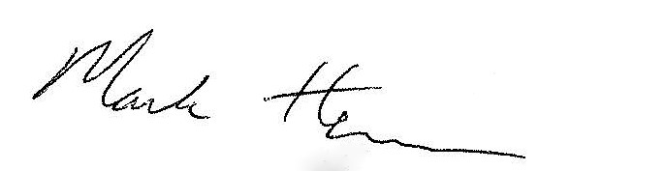 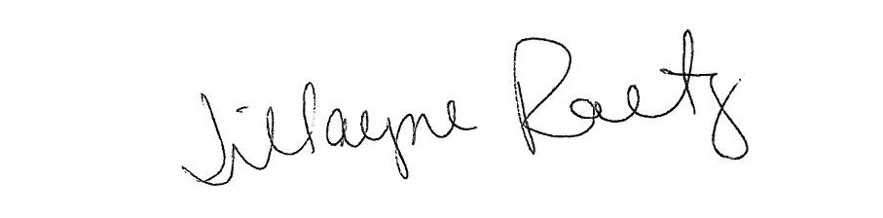

_____________________________ __________________________

President Board Secretary