**ALBERT LEA PORT AUTHORITY**

**MINUTES**

**Wednesday, November 1, 2017- 7:30 a.m.**

**Regular Meeting**

**Albert Lea Business Development Center**

CALL TO ORDER & NOTATION OF ROLL

The Regular Meeting of the Albert Lea Port Authority was called to order on Wednesday, November 1, 2017 at 7:30 a.m. by President Heinemann. Roll was noted by the Board Secretary.

COMMISSIONERS PRESENT: Mike Moore, Rich Murray, Nate Jansen, Mark Heinemann, Sarah Hensley

COMMISSIONERS ABSENT: Vern Rasmussen, Jr., Ginny Larson

EX-OFFICIO MEMBERS PRESENT: Chad Adams, City of Albert Lea representative

EX-OFFICIO MEMBERS ABSENT: Randy Kehr, Business Community representative; Mike Lee, Freeborn County representative

STAFF MEMBERS PRESENT: Ryan Nolander, Executive Director; Noelle Hagen, Small Business & Marketing Manager; Jillayne Raetz, Board Secretary

STAFF MEMBERS ABSENT: None

GUESTS: Wyeth Anderson, City of Albert Lea Intern; Tom Newell, Albert Lea-Freeborn County Chamber of Commerce; Geri Jensen, Albert Lea-Freeborn County Chamber of Commerce

APPROVAL OF MINUTES FROM OCTOBER 4, 2017 MEETING

The minutes from the October 4, 2017 meeting were reviewed. Commissioner Jansen made a motion to approve the minutes as presented, seconded by Commissioner Murray. President Heinemann asked for any discussion and hearing none, the motion carried 5 in favor; 0 opposed.

RESOLUTION PA-17-21 AUTHORIZING PAYMENT OF CLAIMS

The claims were presented for review. Commissioner Jansen made a motion to accept the claims as presented in the amount of $19,930.69, seconded by Commissioner Moore. President Heinemann asked for any discussion and hearing none, the motion carried 5 in favor; 0 opposed. Circled the assessment on Broadway, repaved it. Off the industrial park,

QUARTERLY FINANCIAL REVIEW

Executive Director Ryan Nolander explained that he will be adding a quarterly financial review to the meeting agenda. The purpose of the review will be to get a look at the overall financial situation of the organization each quarter, instead of only visiting during budgeting reviews or special projects. Nolander also went on to note several items in the financial review including; cash is down due to ZRB expansion. Fixed assets, so far with ZRB with construction. Property’s under other assets. Government income, TIFF payment, spec building number 1 and Larson contracting. Rentals are up over last year, due to Streater. Total income decent to TIFF payment and Streater leasing all year. Board of directors fees, fully staffed so that is higher. Building maintanence, professional expenses would be accountant. Total expenses pretty good with inflation. Endres sale is good. Net income good.

EXECUTIVE DIRECTOR’S REPORT

* + ZRB building Project Update
    - Due to the weather, the building project is about 15 days behind schedule. Executive Director Nolander noted that the participation agreement between the Albert Lea Port Authority and Greater Jobs will be completed soon and will be brought to the board for approval in December.
* Project BJ Update
  + The company has made rail access a requirement and is also looking for additional square footage in an existing building. Previously staff pitched the former Fountain Industries building. In the latest proposal, staff has included information on the former Universal Tire building as it once had rail access in the building and could be reconnected.
* Project Brunton Update
  + City Manager Chad Adams and Executive Director Nolander participated in a phone conference this week with Brunton Architects about the Blazing Star Landing and possible development projects.
* Data Center Meetings & Contacts
  + Executive Director Nolander and Brian Skogheim from Freeborn Mower Cooperative Services had a meeting with John Stagemen from Pantheon computers about the potential for a data center in Albert Lea.
* Krieger Beverage Building
  + Edwards Manufacturing signed a lease for 10 years on the building. They plan to bring another line of production to Albert Lea.
* Interstate Meats Building/J&B Wholesale
  + The building is still for sale, a few local parties have shown interest. The asking price has dropped to 700,000 or 800,000.
* VA Project Update
  + On 10/10/17 Executive Director Nolander participated in a conference call and learned that there are currently 5 locations that are VA nursing home. The VA’s ideal nursing home size is 200 beds. There have not been many new nursing homes built as the money to build comes from a fund that is also meant to repair current VA nursing homes and those projects often take precedence over new construction. Last year, only two new VA facilities were approved nationwide. While Minnesota has a large veteran population, it is not as large as other states and may pay a role in whether a location in Minnesota will be chosen. The process to build a VA nursing home is lengthy and may take years to get all the proper work done before presenting the case to the VA.
* Retail Marketing Discussion
  + In Summer 2017, ALEDA had a meeting with Joe Kircharski – formerly with Retail Strategies. Several weeks ago, Retail Strategies met with ALEDA staff and representatives of stakeholders in Albert Lea to discuss what Retail Strategies is proposing they could do in terms of retail attraction for Albert Lea. Discussion was had between the community stakeholders and while the group felt it could be a good opportunity, there are a lot of questions that still need to be answered.
  + The board discussion highlighted several points that will be researched and considered further such as; the success rate in similar communities, feedback from other communities – including communities who have cancelled their contracts with Retail Strategies, and if $40,000 a year be better spent on our community with a different initiative or project to grow tax base.
* Article Discussion (article in packet)
* Quad Graphics is closing their operation in Waseca, MN. Executive Director Nolander has reached out to Val Kvale of the Workforce Development Center in Albert Lea to discuss possibly recruiting the 300+ employees for available jobs in Albert Lea.
* Board Member Terms/Executive Officers
  + Commissioner Jansen’s term is ending at end of the year and he noted that he would like to renew his term on the board. At the January meeting board members will be confirmed and the board officers will be appointed. Current officers: Mark Heinemann – President; Vern Rasmussen – Vice President; Mike Moore – Treasurer.

EX-OFFICIO UPDATE

Freeborn County – Mike Lee, Freeborn County Representative

* Mike Lee was absent and sent an update to Executive Director Nolander.
* Last meeting had mentioned the new buffer ordinance and ditches.
* County is refinancing the new courthouse construction to save the taxpayers money.
* Haven’t heard anything new with VA but did have a conversation with Senator Sparks, he would have more information about the situation.

City of Albert Lea – Chad Adams, City of Albert Lea Representative

* Mayo Clinic agreed to have a facilitated meeting with ??? and City staff. They presented their economic impact study and there are concerns about the information presented.
* The new Fire Department facility project is moving forward. The budget for the project has been set and the site location options are still being considered.
* The former Sons of Norway clubhouse will become The Barn of Chapeau Shores – a wedding and event center owned by Chad and Jayne Iverson. The new conditional use permit has been approved by the council. Adams commended the Iversons for listening to the concerns of the area residents and for changing details of their plan to accommodate them.
* The bid for development of the Freeborn Bank Building was due last week (week of October 23-27, 2017). City of Albert Lea is still working with the developer and hopes to get the information from them soon. There are two other parties interested in the building as well.
* Lee Bjorndal is resigning from his position as City Attorney effective December 1, 2017.

Chamber of Commerce – Tom Newell and Geri Jensen, Business Community Representatives

* Tom Newell and Geri Jensen were present in place of Randy Kehr.
* The Albert Lea-Freeborn County Chamber of Commerce held their annual meeting on October 26, 2017. Good Steward Consulting was recognized as the 2018 Small Business of the Year and Thorne Crest Senior Living Community was recognized as the 2018 Large Business of the Year.
* Randy Kehr has announced that he will be taking medical leave for an undetermined amount of time. Tom Newell has stepped in to serve as Interim Director in Kehr’s absence.

COMMISSIONER/OTHER ITEMS - None

ADJOURNMENT

Commissioner Jansen made a motion to adjourn the meeting, seconded by Commissioner Murray. The motion carried 5 in favor, 0 opposed. The meeting adjourned at 8:35 a.m.

Filed and attested November 1, 2017.

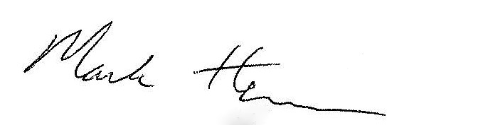 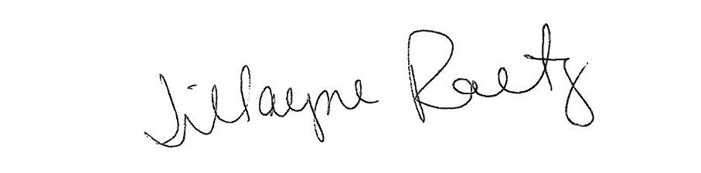

_____________________________ __________________________

President Board Secretary