**ALBERT LEA PORT AUTHORITY**

**MINUTES**

**Wednesday, December 6, 2017- 7:30 a.m.**

**Regular Meeting**

**Albert Lea Business Development Center**

CALL TO ORDER & NOTATION OF ROLL

The Regular Meeting of the Albert Lea Port Authority was called to order on Wednesday, December 6, 2017 at 7:30 a.m. by President Heinemann. Roll was noted by the Board Secretary.

COMMISSIONERS PRESENT: Mike Moore, Rich Murray, Ginny Larson, Mark Heinemann, Sarah Hensley

COMMISSIONERS ABSENT: Nate Jansen, Vern Rasmussen, Jr.

EX-OFFICIO MEMBERS PRESENT: Mike Lee, Freeborn County representative; Chad Adams, City of Albert Lea representative; Tom Newell, Business Community representative;

EX-OFFICIO MEMBERS ABSENT: None

STAFF MEMBERS PRESENT: Ryan Nolander, Executive Director; Noelle Hagen, Small Business & Marketing Manager; Jillayne Raetz, Board Secretary

STAFF MEMBERS ABSENT: None

GUESTS: Brian Skogheim, FMCS; Wyeth Anderson, City of Albert Lea Intern; Jerry Gabrielatos, City of Albert Lea Assistant Manager

APPROVAL OF MINUTES FROM NOVEMBER 1, 2017 MEETING

The minutes from the November 1, 2017 meeting were reviewed. Commissioner Murray made a motion to approve the minutes as presented, seconded by Commissioner Hensley. President Heinemann asked for any discussion and hearing none, the motion carried 5 in favor; 0 opposed.

RESOLUTION PA-17-22 AUTHORIZING PAYMENT OF CLAIMS

The claims were presented for review. Executive Director Ryan Nolander noted expenses for updating the industrial park signs and an ad in Business Xpansion Journal. Commissioner Murray made a motion to accept the claims as presented in the amount of $16,734.52, seconded by Commissioner Moore. President Heinemann asked for any discussion and hearing none, the motion carried 5 in favor; 0 opposed.

RESOLUTION PA-17-23 APPROVING OPERATIONS AGREEMENT

Every three years the operating agreement between the Port Authority and Greater Jobs needs to be renewed. Executive Director Ryan Nolander noted if approved the agreement will continue for another three years. Commissioner Larson made a motion to approve the operations agreement as presented, seconded by Commissioner Hensley. President Heinemann asked for any discussion and hearing none, the motion carried 5 in favor; 0 opposed.

RESOLUTION PA-17-24 APPROVING ALBDC LEASE AGREEMENT

Executive Director Ryan Nolander explained the history of the spec building now known as the Albert Lea Business Development Center (ALBDC) and the agreement between the Port Authority and Greater Jobs for use as a business incubator. The agreement is renewed every three years. Commissioner Moore made a motion to approve the ALBDC lease agreement as presented, seconded by Commissioner Murray. President Heinemann asked for any discussion and hearing none, the motion carried 5 in favor; 0 opposed.

RESOLUTION PA-17-25 APPROVING FINANCING AGREEMENT FOR ZUMBRO RIVER BRAND SPEC BUILDING PROJECT

Executive Director Ryan Nolander explained how the agreement would benefit the Port Authority by helping to relieve some of the upfront cash and ongoing debt burden, and how an investment would help Greater Jobs’ portfolio. Nolander presented the board with financial projections for the Port Authority and Greater Jobs based on Greater Jobs participating or not participating in the project. Commissioner Moore made a motion to approve the financing agreement for Zumbro River Brand spec building project as presented, seconded by Commissioner Larson. President Heinemann asked for any discussion and hearing none, the motion carried 5 in favor; 0 opposed.

EXECUTIVE DIRECTOR’S REPORT

* + Mayo Update
    - A presentation took place December 5th to present the results of the Quorum study on the viability of a full-service hospital in Albert Lea. Discussion followed about the options presented by Quorum.
  + ZRB Building Project Update
    - The building’s siding has been put up, construction is a little behind due to weather. Occupancy date is now January 15th, 2018. ZRB plans to be moved out of ALEDA #1 by February 28th.
  + Streater Warehousing
    - They are currently renting the Ring Can building, but toured ALEDA #1. Streater is potentially interested in moving from the Ring Can space to ALEDA #1.
    - There is an opportunity to possibly back-fill the Ring Can space if Streater leaves the facility with the Albert Lea Gymnastics Club.
  + Great Lakes Polymer Technologies Project
    - Great Lakes Polymer Technology (formerly Bridon) is looking for a third-party manufacturer to custom package their concrete mesh product. Great Lakes Polymer Technologies currently packages the product in house. Executive Director Nolander and Kevin Miland from GLPT have shown the operation to two potential partners.
  + Project BJ Update
    - Project from DEED. They have put that project on hold for one to two years while they invest in Poland due to Brexit.
  + Innovative Seed Project
    - This is the same gentleman ALEDA was working with and had approved a sale of land to in July 2016. He is looking again at opening a seed dealership and is looking at potential properties to building on.
  + Retail Marketing Discussion (see emails in packet)
    - The board reviewed the emails included in the packet. Recommend that staff speaks to references provided. Discussion followed in regards to the investment and whether those dollars should be spent on something like this or in other ways.

EX-OFFICIO UPDATE

Freeborn County – Mike Lee, Freeborn County representative

* Truth and taxation meeting is tomorrow.
* December 19th will be the board meeting to approve the final levy and budget.
* County has approved the demolition bid for the old Oakland school.
* Approved rezoning some property owned by Darv Habben from B-1 to B-2.
* In November the county had a workshop in regards to poverty.

City of Albert Lea – Chad Adams, City of Albert Lea representative

* + Continue to work on housing. Local housing summit to be held February 6th. Targeting those in the housing industry, contractors, financing, etc. Inviting the broader area.
  + Continue to look at potential locations for a new fire station. Start building in 2018.
  + Blazing Star Landing and trail are included in house’s bonding bill. Supposedly the trail is on the DNR’s project short list.
  + Child care is a hot issue in greater MN.
  + Final levy and budget will be discussed and approved December 11th. Looking at 1.20% tax levy increase for debt service, no operating levy increase for 6th year in a row.
* Bank building; Adams and Gabrielatos spoke with Craig Hoium and Rick Mummert in regards to their project’s feasibility report. There is also another interested party in the FBB.
* Kelly Martinez has accepted the interim city attorney role. She is currently a partner in a practice in the Twin Cities but lives in Albert Lea. She will be covering civil and criminal work for Albert Lea as they seek a new city attorney.
* Gabrielatos spoke about the poverty issue in Freeborn County and a project he is working on with Ann Austin.
* Next Experience Albert Lea meeting will be focused on discussing the Main Street program in downtown Albert Lea.
* Continuing to advertise the 5-year tax abatement program for new homes built in Albert Lea. Gabrielatos is working on a letter to send to local contractors and developers.

Chamber of Commerce – Tom Newell, Business Community representative

* Newell shared information about a scholarship available for Riverland students in Freeborn County. Six $2,500 scholarships are available and intended for students in the high skill technology fields of study. There needs to be a community match with each one.
* The Chamber is working with Perry from Big Island Rendezvous to prepare for the annual gourmet auction in January.
* Executive committee is in the process of finding an executive director. They are working through the job description and requirements. They will be asking community leaders such as Ryan Nolander, Chad Adams, and Susie Peterson to assist in the interview and selection process.

COMMISSIONER/OTHER ITEMS –

* Commissioner Moore submitted his resignation. Over the years Moore has provided the board with a significant amount of history and ways to help the economic development agency with their mission and work. Moore is currently serving on the board as treasurer. Commissioner Murray made a motion to accept Commissioner Moore’s resignation as presented, seconded by Commissioner Hensley. President Heinemann asked for any discussion and hearing none, the motion carried 5 in favor; 0 opposed.
* President Heinemann met with Executive Director Nolander to discuss Nolander’s yearly review. Some initiatives they have chosen for 2018 include; monthly retention visits, quarterly finance report, continue to work with the public and businesses to let them know we support them and are here to help and guide them.

*(Commissioner Larson left)*

ADJOURNMENT

Commissioner Murray made a motion to adjourn the meeting, seconded by Commissioner Hensley. The motion carried 4 in favor, 0 opposed. The meeting adjourned at 9:00 a.m.

Filed and attested December 6, 2017.

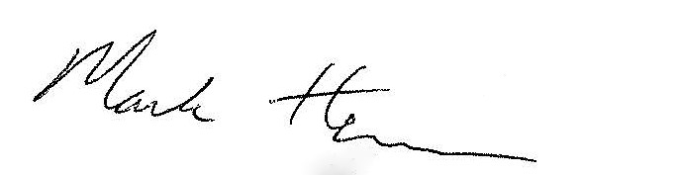 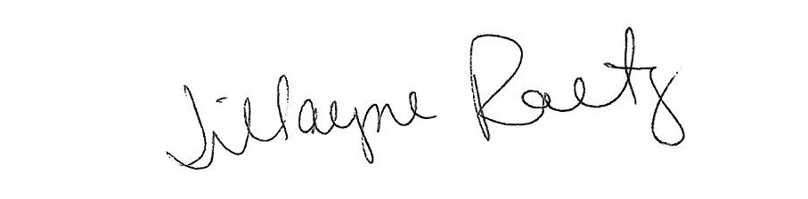

_____________________________ __________________________

President Board Secretary